Year 11 – Forces and Motion

Answer these questions on the paper provided. Do not write on this sheet.
Show full working for all questions and remember to give units with your answers.

- A “Formula 1” car can accelerate very rapidly. The car in this question has a mass of 640kg.

  - The car travels at 60m/s on a straight section of the track. How far will the car travel in 4 seconds?

  - The car takes 3.8 seconds to accelerate from rest to a speed of 55ms⁻¹ (just over 120mph). Calculate the acceleration of the car.

  - What force does the engine need to exert to produce an acceleration of 5m/s²? (The mass of the car, including the driver, is 640kg).

  - Explain why the car must have a top speed by comparing how the forces due to friction, air resistance and the driving force of the engine change.

  - The car (mass 640kg) is travelling at 55m/s when it approaches a corner.

    - What is the kinetic energy of the car?

    - The car slows down to 25m/s to take the corner. How much does the kinetic energy of the car decrease?

    - Find the distance over which the car’s speed is reduced, given that the force exerted by the brakes is 20,000N.

- Most cars cannot brake as effectively as a Formula 1 car. A typical car decelerates at a rate of 4.5m/s² when braking.

  - How long would this car take to brake from 30m/s to a stop?
  - What will be the average speed of the car during braking?
  - What will the braking distance be?
  - What will the thinking distance be at 30m/s, given that the driver was reacting to a hazard and has a reaction time of 0.9 seconds.

  - Find the total stopping distance of the car.

- The stopping distance of a car can be affected by many factors. State one factor which could affect:
  - Only thinking distance.
  - Only braking distance.
  - Both braking distance and thinking distance.

- A model rocket is fired vertically upwards. The model rocket has a mass of 0.4kg.

  - The gravitational field strength on Earth “g” is 9.8 N/kg. What is the weight of the rocket?
  - How much work would be done lifting the rocket to a height of 100m?

- The car in the diagram has two forces acting on it.
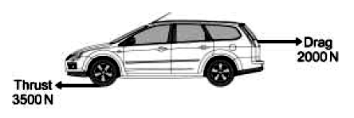

  - Calculate the size and direction of the resultant force.
  - The mass of the car is 1200kg. Calculate the car’s acceleration.

- The graph below shows the speed of a cyclist in a race over a period of 120seconds.
  - The cyclists are already moving when they cross the “start” line. What speed is this cyclist travelling when the timer starts?
  - How long does the cyclist maintain a constant speed?
  - Suggest two forces which would be acting against the cyclist as he is moving.
  - Calculate the acceleration of the cyclist in the first 30 seconds.
  - Calculate the distance travelled by the cyclist in the last 30 seconds of the race.
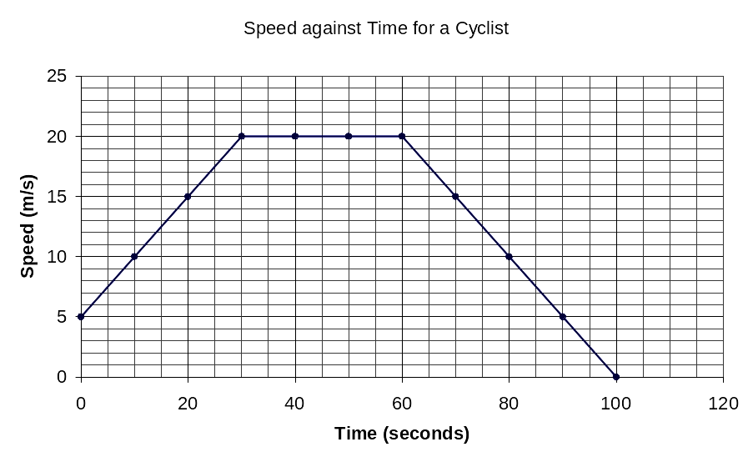
  - Calculate the total distance travelled by the cyclist over the whole 100seconds.

