Look at the five traces below.

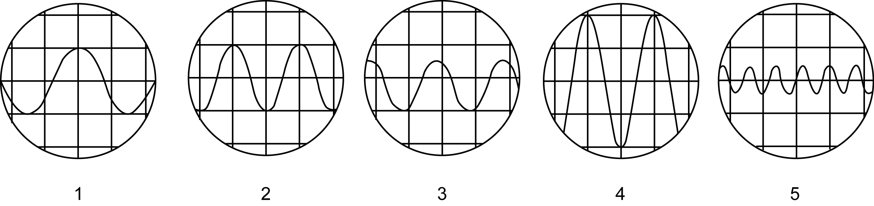

Which trace or traces:

Which…

- has the highest pitch? _____
- is the loudest? _____
- has the highest frequency? _____
- has the lowest frequency? _____
- have the same volume? _____ and _____

Look at the five traces below.

Which trace or traces:

Which…

- has the highest pitch? _____
- is the loudest? _____
- has the highest frequency? _____
- has the lowest frequency? _____
- have the same volume? _____ and _____

