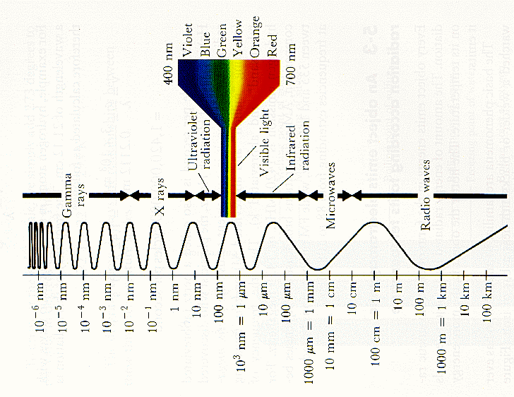
- highest frequency
- highest energy
- shortest wavelength
- lowest frequency
- lowest energy
- longest wavelength
Sources
Uses
Dangers

Gamma rays
Microwaves
Radiowaves
Infrared
Ultra Violet

Visible Light

X Rays

