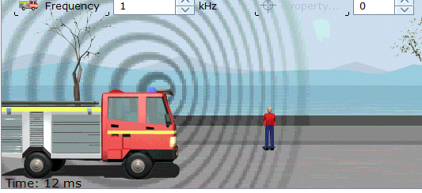
Truck is moving forwards at high speed
Truck is moving forwards at high speed
Truck is moving forwards at high speed
Truck is moving forwards at high speed
Truck is moving forwards at high speed
Truck is moving forwards at high speed

