Evaporation

The particles in a liquid have energy.

As the particles vibrate there are many collisions between them. This causes some particles to have more energy and other particles to have less energy. We say there is a "varying distribution of energies".

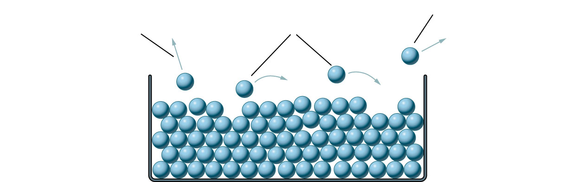

Some of the particles will gain enough energy to escape from the top surface of the liquid. Write each of the following labels in the correct place on the diagram:

some particles escape from the liquid completely.
particles with a high enough energy can escape from the surface of the liquid.
some particles fall back into the liquid.

The _____________ of the liquid depends on the __________ thermal energy of the particles in the liquid. The particles with the most energy will __________from the ______________ of the liquid. If the most ____________ particles escape the average energy of the particles ___________. This means that the fluid _________ as evaporation takes place.
escape cools energetic temperature
decreases surface average

