Condensation

Condensation is the opposite of evaporation. Particles in a vapour (gaseous) state lose energy and condense back into a liquid state. This process of condensing usually happens when the particles encounter a cool surface.
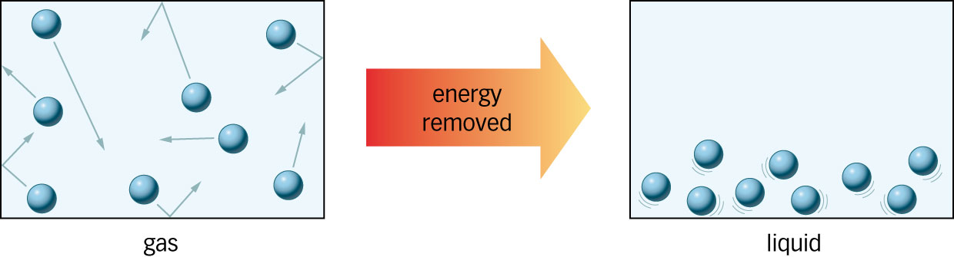

---------------------------------------------------------------------------------------------

Condensation

Condensation is the opposite of evaporation. Particles in a vapour (gaseous) state lose energy and condense back into a liquid state. This process of condensing usually happens when the particles encounter a cool surface.

---------------------------------------------------------------------------------------------

Condensation

Condensation is the opposite of evaporation. Particles in a vapour (gaseous) state lose energy and condense back into a liquid state. This process of condensing usually happens when the particles encounter a cool surface.

