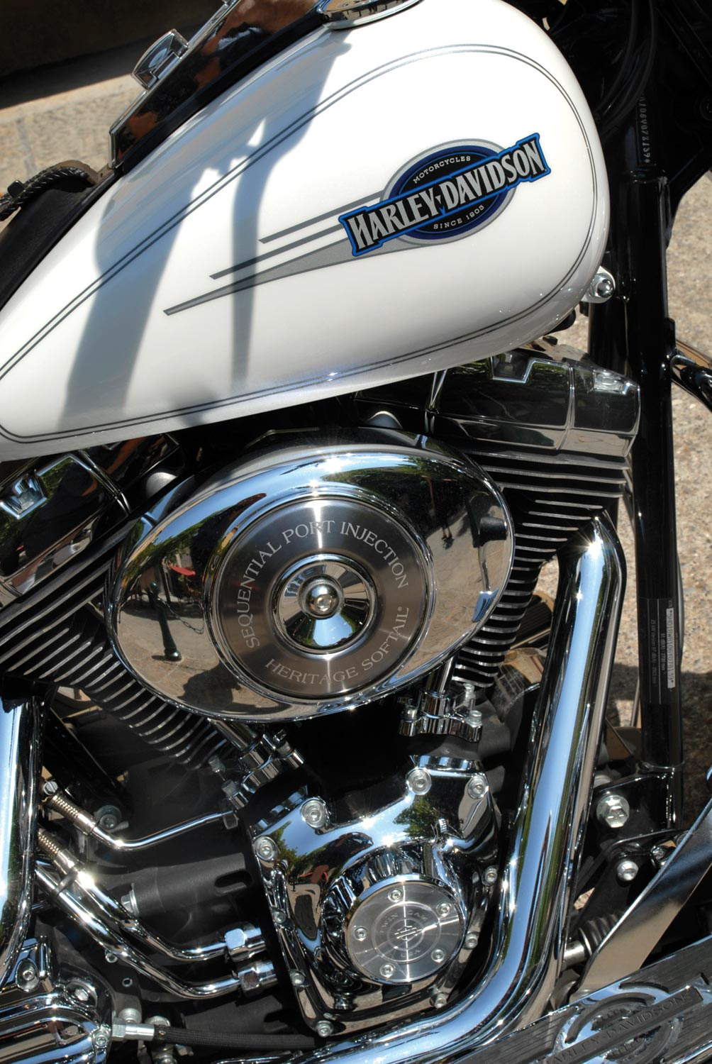
1. Look at this radiator. Can you think of two elements in its design that help it transfer thermal energy?

2. Can you think of a way the transfer of thermal energy could be increased still further?



3. What method does this heat sink use to maximise thermal energy transfer? How could the rate of transfer of thermal energy be increased even further?

1. Look at this radiator. Can you think of two elements in its design that help it transfer thermal energy?

2. Can you think of a way the transfer of thermal energy could be increased still further?

3. What method does this heat sink use to maximise thermal energy transfer? How could the rate of transfer of thermal energy be increased even further?

