The Cost of Electricity
Remember:

1 kW = 1000 W
1 kWh = 1 ‘Unit’

Energy transferred = power x time
(in kilowatt-hours, kWh) (in kW) (in hours)

Cost of electricity = number of units (kWh) x cost of 1 unit

Answer
Energy transferred = power x time
= 2 kW x 3 hours
= 6kWh (=6 Units)

Cost = number of Units x 14p
= 6 kWh x 14p
= 84p
Example:
A 2000W electric heater is used for 3 hours.
What is the cost at 14p per unit?

- Calculate the number of “Units” of electricity used when:
  - A 2kW electric heater is used for 10 hours.
  - A 3kW immersion heater is used for 4 hours.
  - A 2kW heater is used for 30 minutes.
  - A 100W lamp is used for 10 hours.
  - A 600W hairdryer is used for 10 minutes.
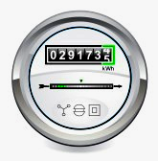

- An electricity meter reading is 29173 Units. One week later, the reading is 29373 units.
  - How many Units were used?
  - What is the cost at 14p per Unit?

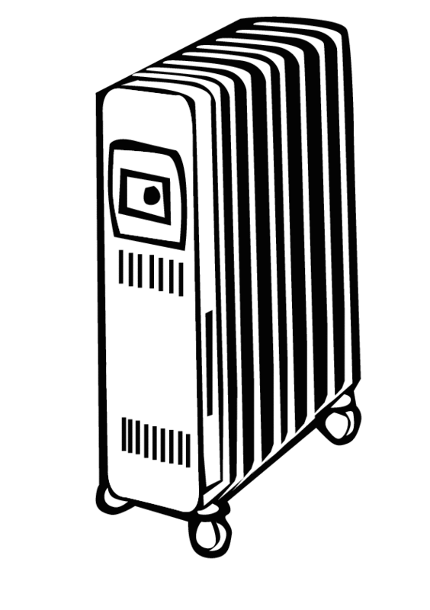
- A 2kW electric heater is used for 4 hours.
The electricity costs 15p per unit.
  - How many Units (kWh) are used?
  - What is the cost?

- A 2kW heater, a 300W television and two 100W lamps are switched on from 6pm to 11pm.
What is the cost at 14p per kWh?

- An electric cooker has an oven rated at 3kW, a grill rated at 2kW, and 4 rings each rated at 500W.
  - What is the cost if all parts are switched on for 30 minutes? (1 unit costs 14p)
  - Are the different heating elements connected in series or parallel? Explain your answer.

