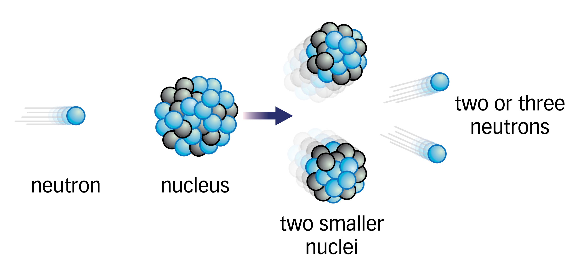
Nuclear Fission and Fusion
Nuclear Fission:

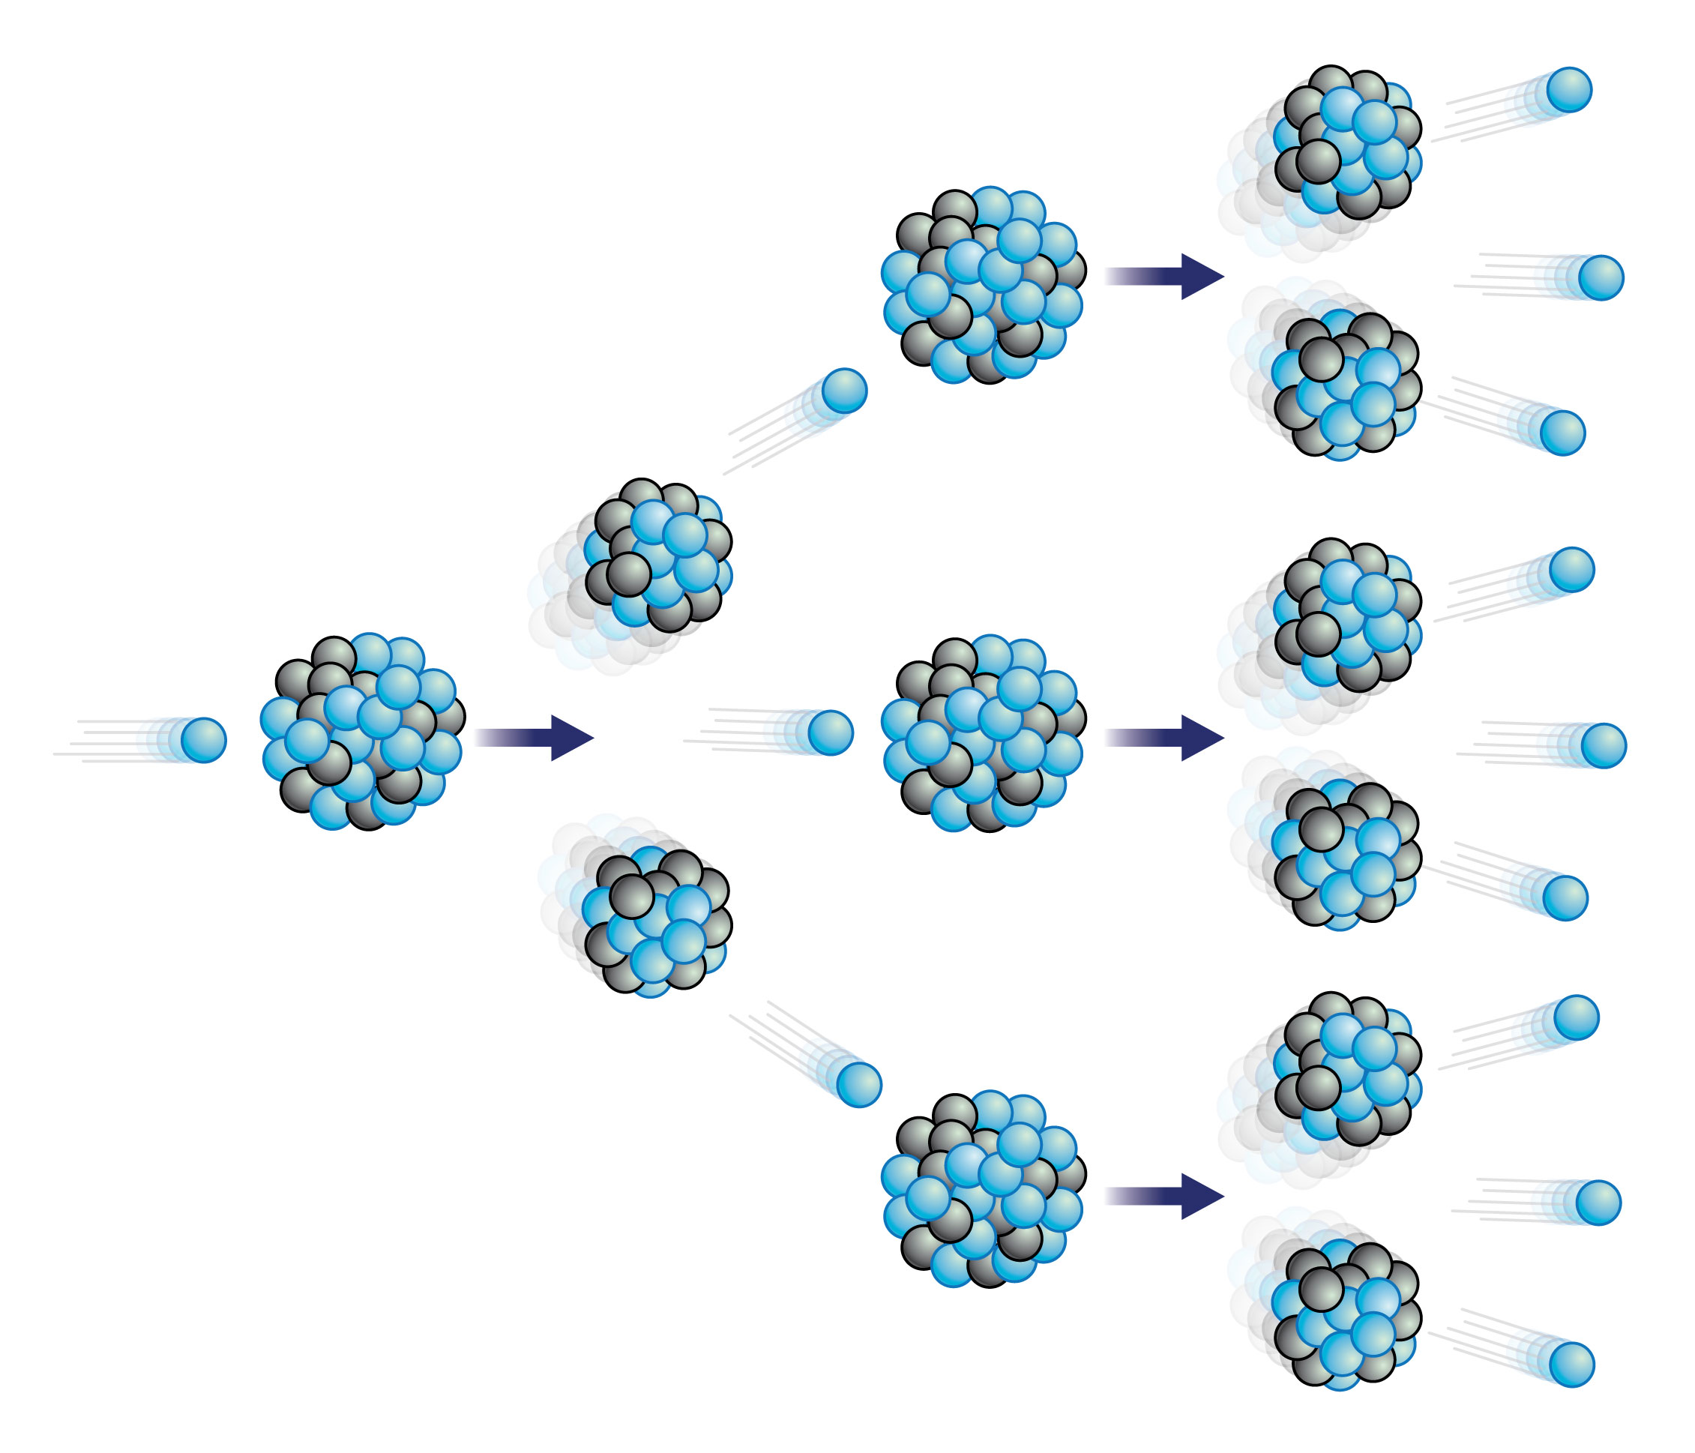
Chain Reaction:

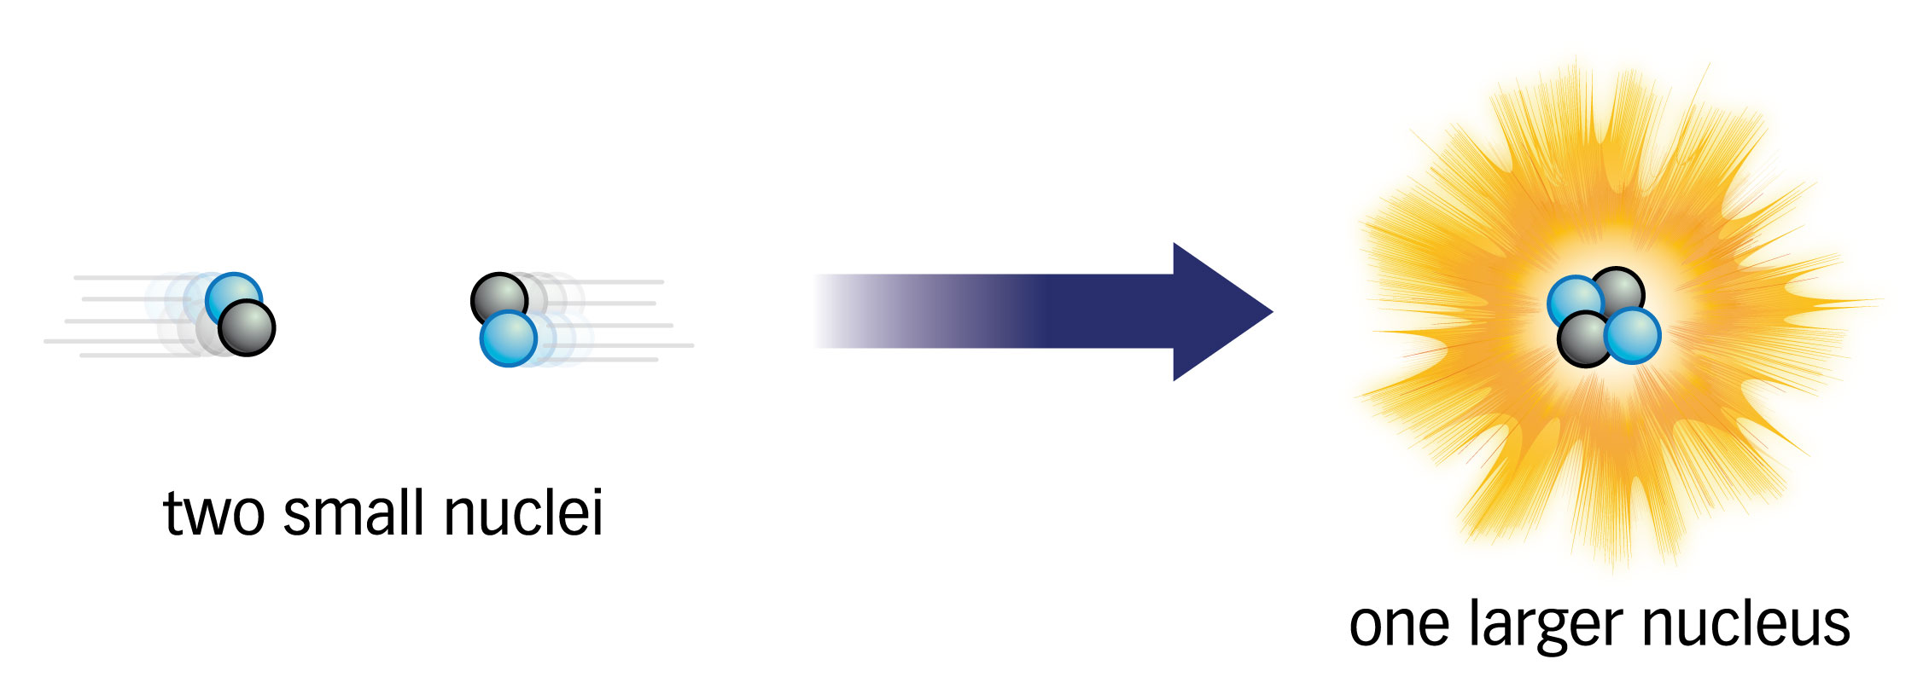
Nuclear Fusion:

