The Structure of the Atom


Our ideas of atomic structure have changed considerably since the beginning of the 20th Century. The ‘plum pudding’ model was suggested by Thomson in 1906 and comprised a sphere of positive charge with electrons dotted about like the plums or raisins in our plum pudding.

In 1910 the work of Geiger and Marsden (working with Rutherford, one of Thomson’s students) produced some results which did not fit with Thomson’s model. The experiment involved bombarding a thin sheet of gold foil with α-particles (helium nuclei), and observing the deflection of the particles as they emerged. The apparatus is depicted in the diagram below. Each time a particle was deflected and hit the zinc-sulphide disc, a small flash of light was produced, and the number of flashes was counted over a set period. The microscope and zinc-sulphide disc were then moved, and observations repeated at a different angle.
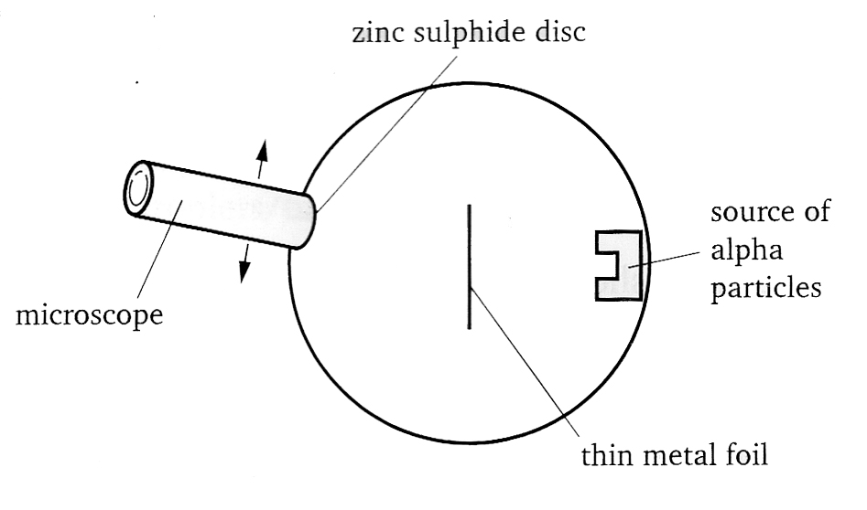
It was found that most of the particles were either not deflected at all, or deflected by a small angle.

Some, however, were deflected by very large angles or even back-scattered (deflected by 180°).

It was known that the α-particles were positively charged and had a significant mass. As such it was concluded that:

1. most of an atom is empty space
2. the mass of an atom is concentrated in a very small nucleus
3. the nucleus is positively charged

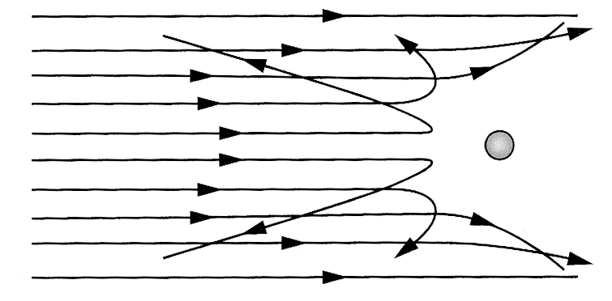
The diagram on the right shows deflection of the incoming α-particles as they approach the nucleus. We can see that particles which closely approach the nucleus are deflected by a very large angle due to the electrostatic repulsion between the α-particle and the positively charged nucleus.

The next step in developing our picture of the atom as we now know it was to determine what the atomic nucleus consisted of. All that was known was that it comprised most of the mass of the atom, was very small, and positively charged.

It was initially thought that the nucleus contained both protons and electrons. This idea presented a number of difficulties, but these were resolved with the discovery of the neutron by Chadwick in 1932.

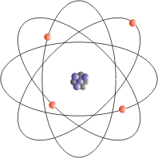
Our current picture of the atom would look something like the diagrams here, with the protons and neutrons arranged in a tightly packed nucleus, and the electrons orbiting rapidly around it. Note that the electrons are not moving along clearly defined orbitals, as the diagram might imply, but instead can be visualised as a ‘cloud’ around the nucleus.


So, we have all our constituents of the atom – the heavier protons and neutrons residing in the nucleus, the electrons orbiting around it, and nothing but a lot of empty space in between…

