Structure of the atom

You should be able to describe the nuclear model of the atom.

The nuclear model
Atoms contain three sub-atomic particles called protons, neutrons and electrons. The protons and neutrons are found in the nucleus at the centre of the atom, and the electrons are arranged in energy levels or shells around the nucleus.

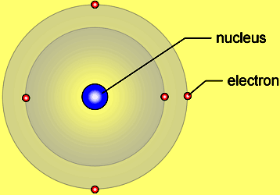

The table shows the properties of these three sub-atomic particles.
Particle | Relative mass | Relative charge
Proton | 1 | +1
Neutron | 1 | 0
Electron | almost zero | –1

The number of electrons in an atom is always the same as the number of protons, so atoms are electrically neutral overall.

Atoms can lose or gain electrons. When they do, they form charged particles called ions:
- If an atom loses one or more electrons it becomes a positively charged ion.
- If an atom gains one or more electrons it becomes a negatively charged ion.

Isotopes
Atomic number and mass number
The number of protons in the nucleus of an atom is called its atomic number:
- The atoms of a particular element all have the same number of protons.
- The atoms of different elements have different numbers of protons.
The total number of protons and neutrons in an atom is called its mass number.

The proton number is shown below the chemical symbol and the mass number is shown above. In the example below, the atomic number is 17 and the mass number is 35. This means that each of these atoms has:
- 17 protons
- 17 electrons
- 35 – 17 = 18 neutrons
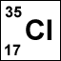
The full chemical symbol for chlorine-35

Isotopes
Isotopes are the atoms of an element with different numbers of neutrons. They have the same proton number, but different mass numbers.
The table describes three isotopes of hydrogen.
isotope | 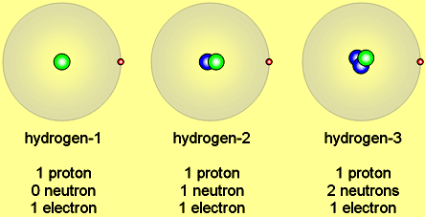
symbol | 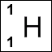 | 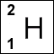 | 