Balanced and Unbalanced Forces II

For each of the following, calculate the size of the resultant force acting on the car, and explain what happens to the motion of the car:

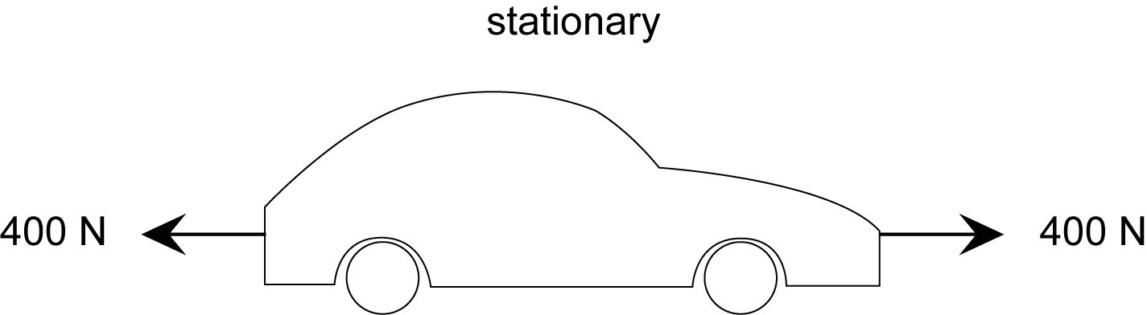  Net force = ________  What the car will do next: | 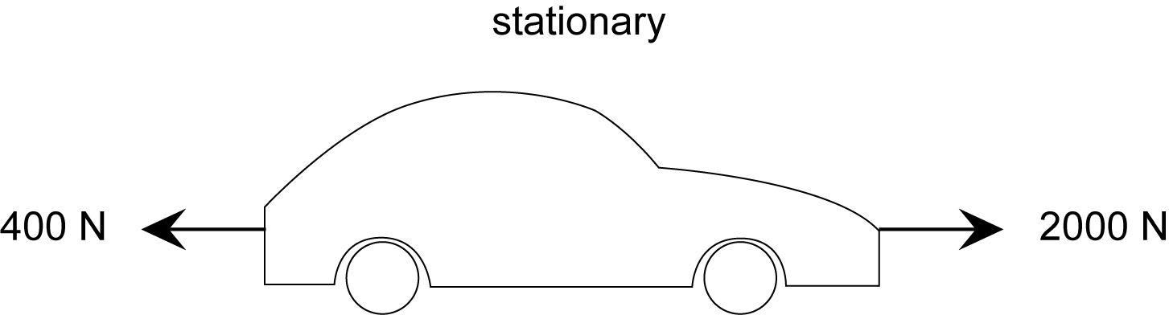  Net force = ________  What the car will do next:
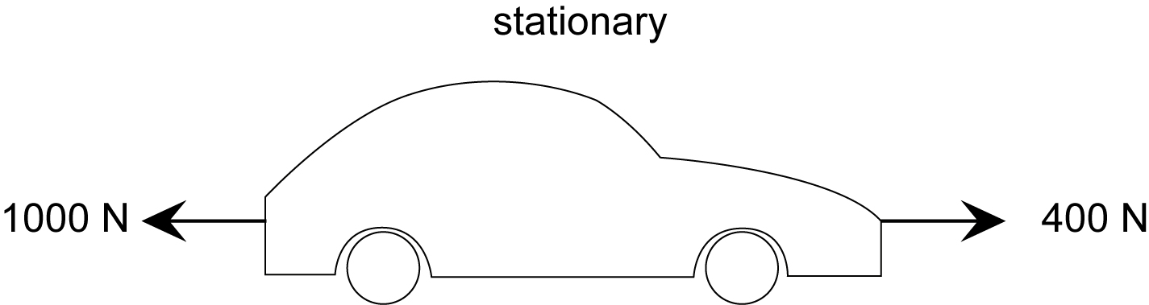  Net force = ________  What the car will do next: | 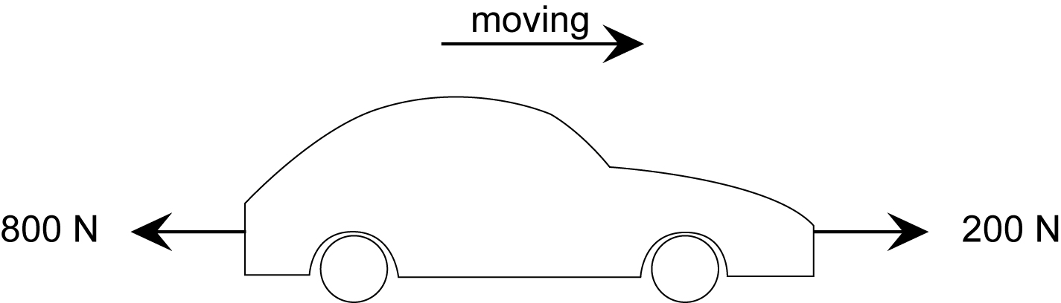  Net force = ________  What the car will do next:
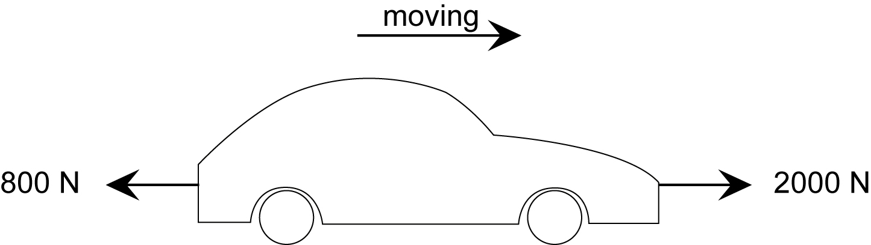  Net force = ________  What the car will do next: | 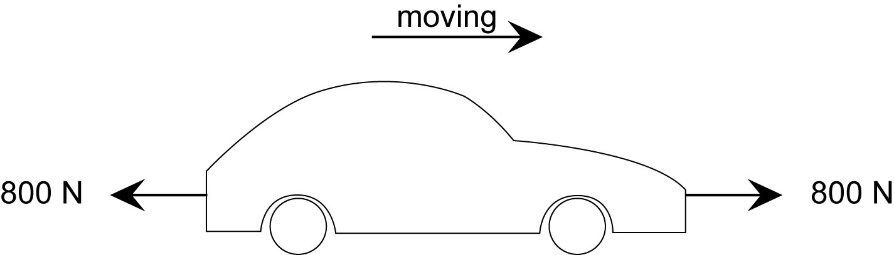  Net force = ________  What the car will do next:

