Resultant force
- Read the sentences below and delete the incorrect part of the sentence:

If there is no resultant force acting on a stationary object then the object will remain stationary/start to move.

If there is no resultant force acting on a moving object then the object will keep going at a steady speed/slow down/get faster.

- Calculate the resultant force acting on the car in the diagram below:

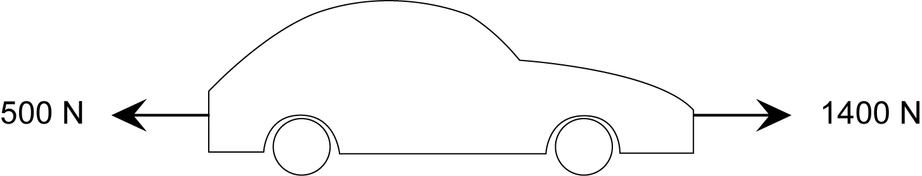

Force = _________________

- Fill in the gaps in the sentences below:

A car travelling at a constant speed of 80 km/hr is not accelerating (speeding up or slowing down). However, there are still forces acting on the car. The car’s engine provides a force called _____________ . The forces pulling backwards on the car are _____________ and _____________________. If the car is going at a constant speed, then we know that the backwards forces must be _____________ __________ ______________ as the forward force. The resultant force acting on the car must be _________.
If the forwards force is bigger than the sum of the backwards forces, the car will ____________ _______________. If the sum of the backwards forces is bigger than the thrust, the car will _______________ ___________.

