Revision
QUIZ
31 Circuits

Use these questions to help you revise (cover the right-hand side with a sheet of paper).

1 | What is an electric current? |  | ... | a flow of electrons (–), moving from the  negative terminal to the positive terminal.
2 | Where in a circuit should you put an ammeter? |  | ... | in series with the component whose current  you want to measure.
3 | Where in a circuit should you put a voltmeter? |  | ... | in parallel, across the component whose p.d.  you want to measure.
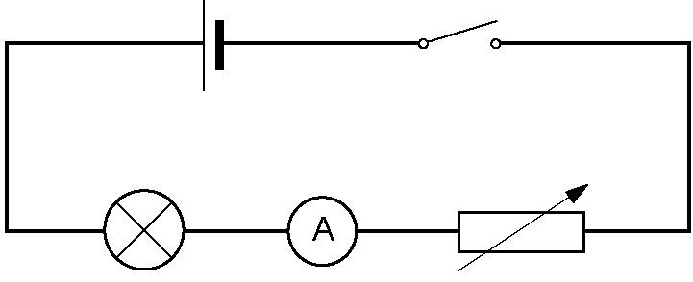
4 | Draw a circuit diagram of a cell, switch, lamp,  ammeter and variable resistor in series. |  | ...
5 | When a p.d. of 10 V is applied across a resistor,  2 A flows. What is the resistance? |  | ... | resistance, |  | R $=\frac{p\text{.}d\text{.}\text{, }V}{\text{current, }I}$  $=\frac{\text{10 V}}{\text{2 A}}=\text{5 ohms }(5Ω)$
6 | A resistance of 4 Ω is carrying a current of 2 A,  and is in series with a resistor of 6 Ω.  What is the total resistance and what is the  current through the 6 Ω resistor? |  | ... | total resistance = 4 Ω + 6 Ω = 10 Ω  current through each resistor (in series) = 2 A
7 | A resistor of 2 Ω is in parallel with a resistor |  | ... | the smaller resistor (2 Ω) has the bigger
7 | of 4 Ω.  Which resistor has the bigger current? |  |  | current. (It will be twice as big.)
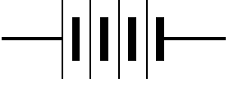8 | In the diagram,  each cell has a  p.d. of 1.5 V.  What is the total p.d.? |  | ... | 6 V
9 | What does the slope of a current–voltage  graph tell you? |  | ... | the steeper the graph, the less the  resistance.
10 | Why is the current–voltage graph for a  filament lamp a curved line? (p. 259) |  | ... | as more current flows, the metal filament  gets hotter, so its resistance increases,  so the graph gets flatter.
11 | What do the letters MCB and RCD stand for? |  | … | Minature circuit breaker and Residual Current device
12 | What advantage does a circuit breaker have over a fuse? |  |  | Circuit breakers can be reset, whereas fuses have to be replaced.

