Investigation planning sheet – current voltage graph of a component

Investigate how the resistance of a component changes as the current through it changes

Think about :
- How can you use the variable resistor in this circuit to change the voltage and current?
- How many different values of voltage and current will you need?
- How could you change the above circuit to investigate a bulb or a diode?

- For each set of readings :
- What measurements will you make?
- How many readings will you take?
- How will you record your results?
- How will you make sure you do not damage the component?

- Ask your teacher to check your circuit before
you begin the investigation.

- For each set of results, plot a graph of current (y axis) against voltage (x axis).

- Explain the conclusions you draw from your
results.
Are the graphs the same shape?
What happens to the resistance of each component as the voltage is increased?

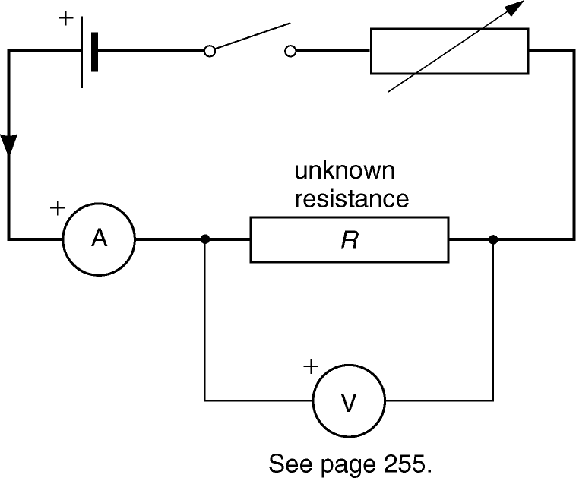

You might choose to use some of these :
ammeter
voltmeter
low-voltage power supply
variable resistor
connecting leads, crocodile clips
wires of nichrome or constantan to make the resistor
(all of the same diameter, eg. 0.31 mm)
Bulb
Diode or LED

potential difference (in V)
current (in A)
Resistance =
(in Ω)

