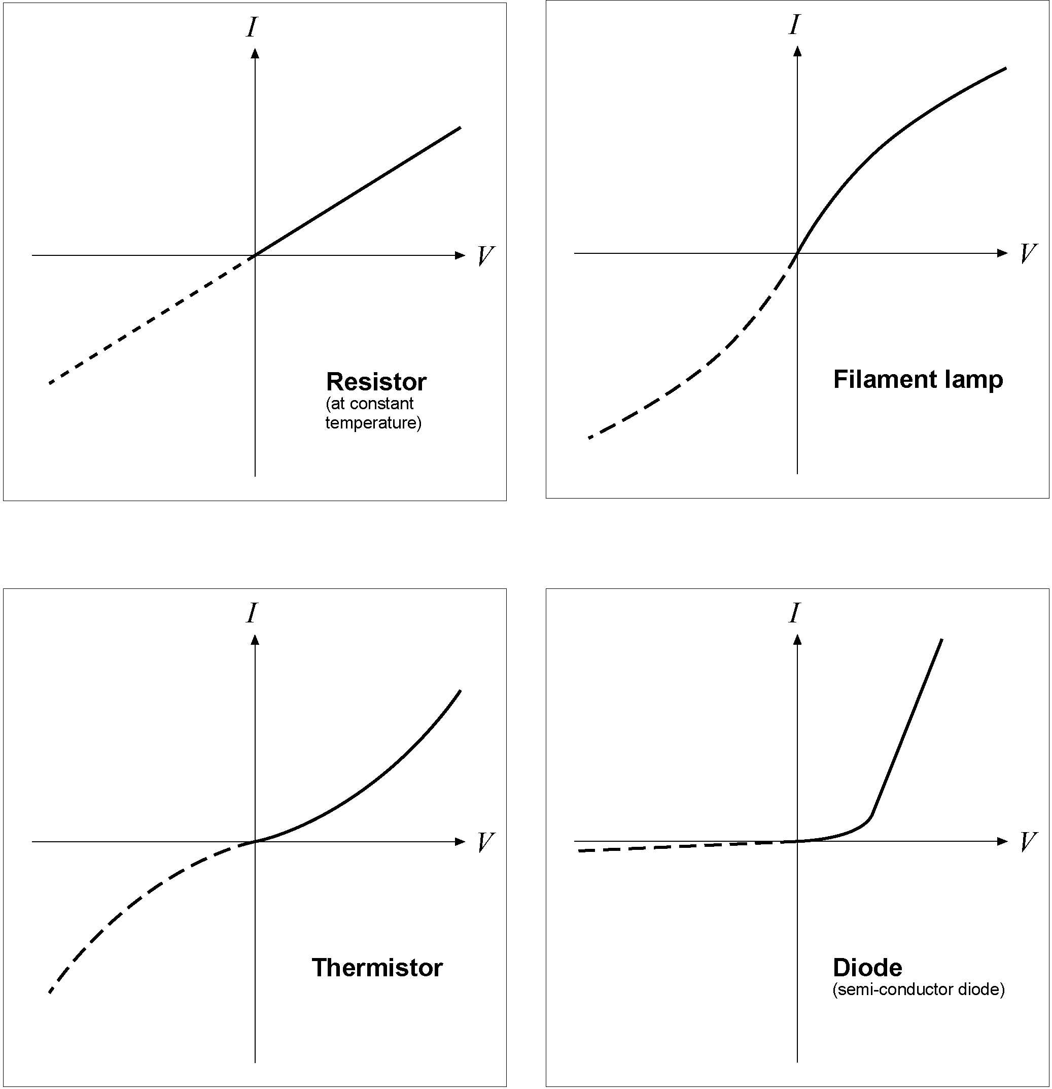
The diagrams show graphs of the current, I against the voltage, V
for 4 devices:



Current Voltage graphs

- Compare these graphs with the ones shown on in your revision guide
The dashed lines show what happens when the voltage V is reversed,
to push the current the other way.

- For each graph, explain carefully what happens,
– when the current is flowing in the ‘forward’ direction (the solid line),
– when the current is reversed (the dashed line).

