Current Voltage graph – graph plotting exercise

Some pupils connected up the circuit shown below.
They used the variable resistor to alter the voltage across the resistance wire, so the current
flowing through it varied. Their results are given in the table :
Voltage across | Current through
wire (volts) | wire (amps)
0.25 | 0.05
0.50 | 0.10
0.85 | 0.15
1.00 | 0.20
1.25 | 0.25
1.50 | 0.30
1.70 | 0.35
2.00 | 0.40
2.25 | 0.45
2.50 | 0.50

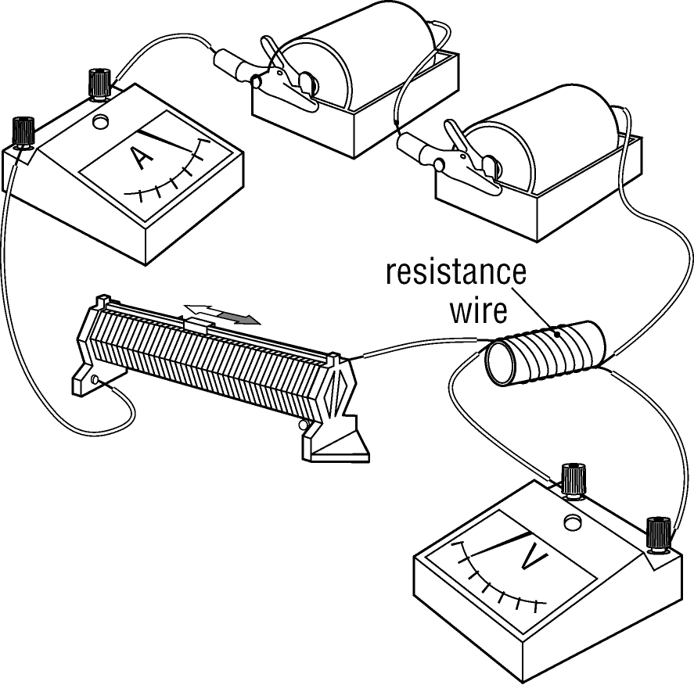


1. Plot the results from the
circuit investigation on this
grid. Choose your scales carefully.

2. Draw a line of best fit.

3. What relationship do you
notice between the voltage
across the bulb and the
current through it ?

4. What would the current be
when the voltage is 1.10 V ?

_________________________

5. (more difficult)
Work out the resistance of the wire

