Symbol | Component
 | cell
 | power supply
 | bulb / lamp
 | ammeter
 | voltmeter
 | resistor
 | open switch
 | motor
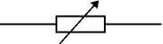 | variable resistor
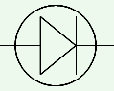 | diode
 | Light Emitting Diode (LED)
 | fuse
 | loudspeaker

Symbol | Component
 | cell
 | power supply
 | bulb / lamp
 | ammeter
 | voltmeter
 | resistor
 | open switch
 | motor
 | variable resistor
 | diode
 | Light Emitting Diode (LED)
 | fuse
 | loudspeaker

