A Speeding Train |  |  | Chemical  Energy
A Warm Oven |  |  | Kinetic  Energy
A Mains Electrical Socket | 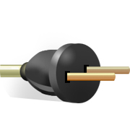 |  | Light Energy
A Piece of Coal |  |  | Heat  Energy
A Stretched Rubber Band |  |  | Gravitational Energy
A Stereo System |  |  | Electrical  Energy
A Keyring Laser Pointer | 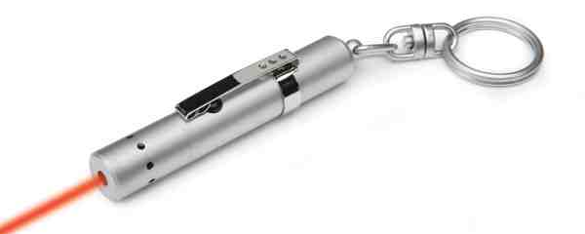 |  | Nuclear Energy
A Book on a high shelf | 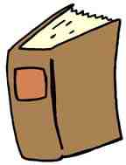 |  | Sound  Energy
A Uranium Fuel Rod for a Nuclear Power Station | 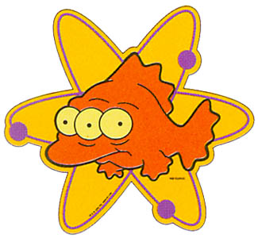 |  | Elastic  Energy

